**Guide to Using the New**

**ELEFAN System**

Aaron Greenberg

and

Daniel Pauly

Fisheries Centre, University of British Columbia, Vancouver, B.C., Canada

**Abstract**

The new release of the ELEFAN system presented here is written as a self-contained software in R. It allows limited manipulation of length-frequency (L/F) data, its main input, then use these L/F data to estimate the parameters of the von Bertalanffy Growth Function (VBGF), with or without accounting for seasonal growth oscillations, and total mortality (Z) from a catch curve. The graphic user interface that was developed for navigating between the different routines required for estimation of the VBGF’s parameters, and of Z, is presented in form of screenshots, along with the basic principe behind each of each of these routines, and their input and output.

**Introduction**

The historical development of length-frequency (l/F) analysis for the purpose of estimating growth and related vital statistics of fish and aquatic invertebrates have been recalled by Pauly (2013; this volume). His Figure 3, here reproduced as our Figure 1 provides the structure to this account.

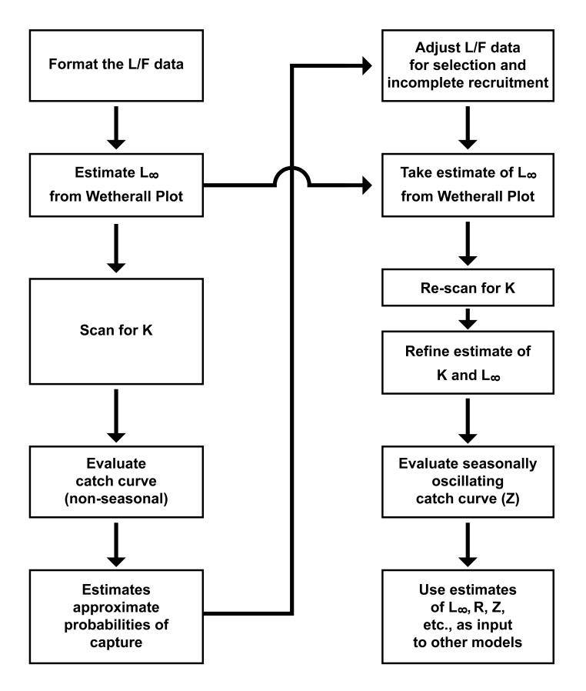

Figure 1. Flowchart of the ELEFAN system as implemented here, showing inputs, outputs and their subsequent analysis when appropriate. The definitions of the different parameters in this figure (Z, F, K, etc.) are given in Pauly (2013, this volume), which also features this figure.

There are five different panels that make up the new version of ELEFAN's GUI. The left side of each panel contains a combination of sliders, dropdown menus, and buttons that allow the user to interact with ELEFAN. The right side of ELEFAN contains a window that displays all the output. These panels allow the user to complete the workflow shown in figure one. The panels are arranged from left to right as enumerated in the following list.

1. Data Display - Reads in data from preformatted plan text inputs and displays the raw data. (Can be changed to Excel files in subsequent versions.)
2. Length Frequency plots – Plots both the raw data and the length frequency data and has the capability to overlay a growth curve.
3. Wetherall Plot- Makes a Wetherrall plot to estimate Linf
4. Kscan- Provides tools to scan for K. Can take both variable and fixed starting points.
5. Catch curve- Computes non-seasonally corrected catch curve and capture probabilities. Adjusts LF data for selection and incomplete recruitment.

In the remainder of this document we show screenshots of the new version of ELEFAN, working through an example of new ELEFAN analyzing the Abra Alba data set. The first screenshot shows the Data Display page. Under the USAID logo are the buttons that prompt the user to input data. Under the tabs reading Date and Data are tables showing the Abra Alba data. The Date tab displays the list of sample dates associated with sample numbers. The Data tab displays the midlengths of the length frequency classes under the column denoted Values and the length frequency data below the sample numbers denoted as d1-d7. Upon clicking on the Date file and Length file the user is prompted to select a data file on their harddrive using a file explorer application.

An example of the length file is included as alba_abra.dat and an example of a date file is included as dateabra_alba.dat. A description...

Once the data has been read into new ELEFAN the next step is to visualize both the raw length frequency data and the restructured data. In the next two figures, I show the the raw and restructured abra alba data. These plots are made by clicking on the Length Frequency Plots tab and pressing the button marked Make the plots. If the value of K set in the K slider is zero no growth curve will be drawn, after making the Wetherall plot we will return to the Length Frequency Plots tab and show how to overlay a growth curve on the length frequency data. It is easy to switch between the raw and restructured data by clicking on the tabs marked LF plot and Peaks plot.

A description...

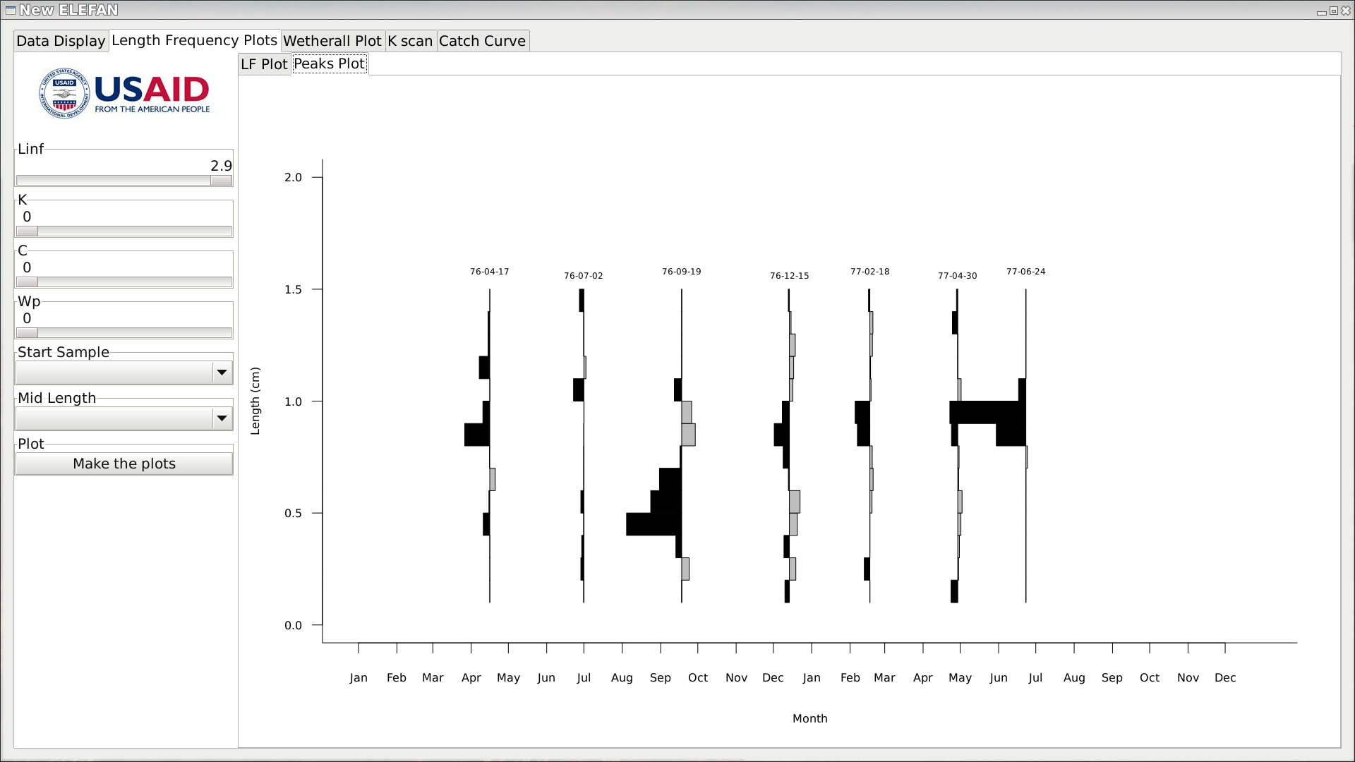

We now use the Wetherall Plot to estimate Linf. As before the user clicks the tab marked Wetherall Plot to move to the routine that makes the Wetherall plot. Under the USAID logo, the user selects the number of points to use and clicks the Make the plots button. In the upper left corner of the plot window, the relevent information about the Linf estimate is shown.

A description...

Now we return to the Length Frequency plot tab and overlay a seasonal growth curve on the data. Under the USAID logo it is possible to set the parameters that are needed to determine a growth curve (Linf, K, C, WP) and the starting sample and mid length. The blue dot in the plot shows the starting point of the growth curve. In the upper left corner is the goodness of fit value of the growth curve. The goodness of fit criteria is displayed to four significant digits in the upper left hand corner of the plot.

A description...

There are two tools that can help find the optimal value of K, as defined by the goodness of fit criteria. Both of these tools are available in the K scan tab of the GUI. In the K scan tab of the GUI the user specifies Linf, C, and the Winter point using the sliders shown below the USAID logo.

The user has a choice of either scaning for K with variable starting point or scaning for K with a fixed starting point. If the user wants to scan for K with a variable starting point the user should click on the Compute Full Kscan button, wait until the scan is complete, then press the Full Kscan button plotting button. The user can smooth the resulting Kscan plot by sliding the Moving Average Window slider from the left to the right and clicking on the Full Kscan plot button again. The light grey line is unsmoothed goodness of fit curve and the dark black line is smoothed goodness of fit curve. The orange dot represents the maximum of the unsmoothed goodness of fit curve and the blue dot represents the maximum of the smoothed goodness of fit curve. The user can make a simular plot for a fixed starting point by specifying a starting sample and midlength in the drop down menus and using the Compute Fixed Kscan buttons.

The final routine computes a nonseasonal catch curve. It takes in the parameters that have been estimated and computes both the catch curve and corrects the data for selectivity and incomplete recruitment. 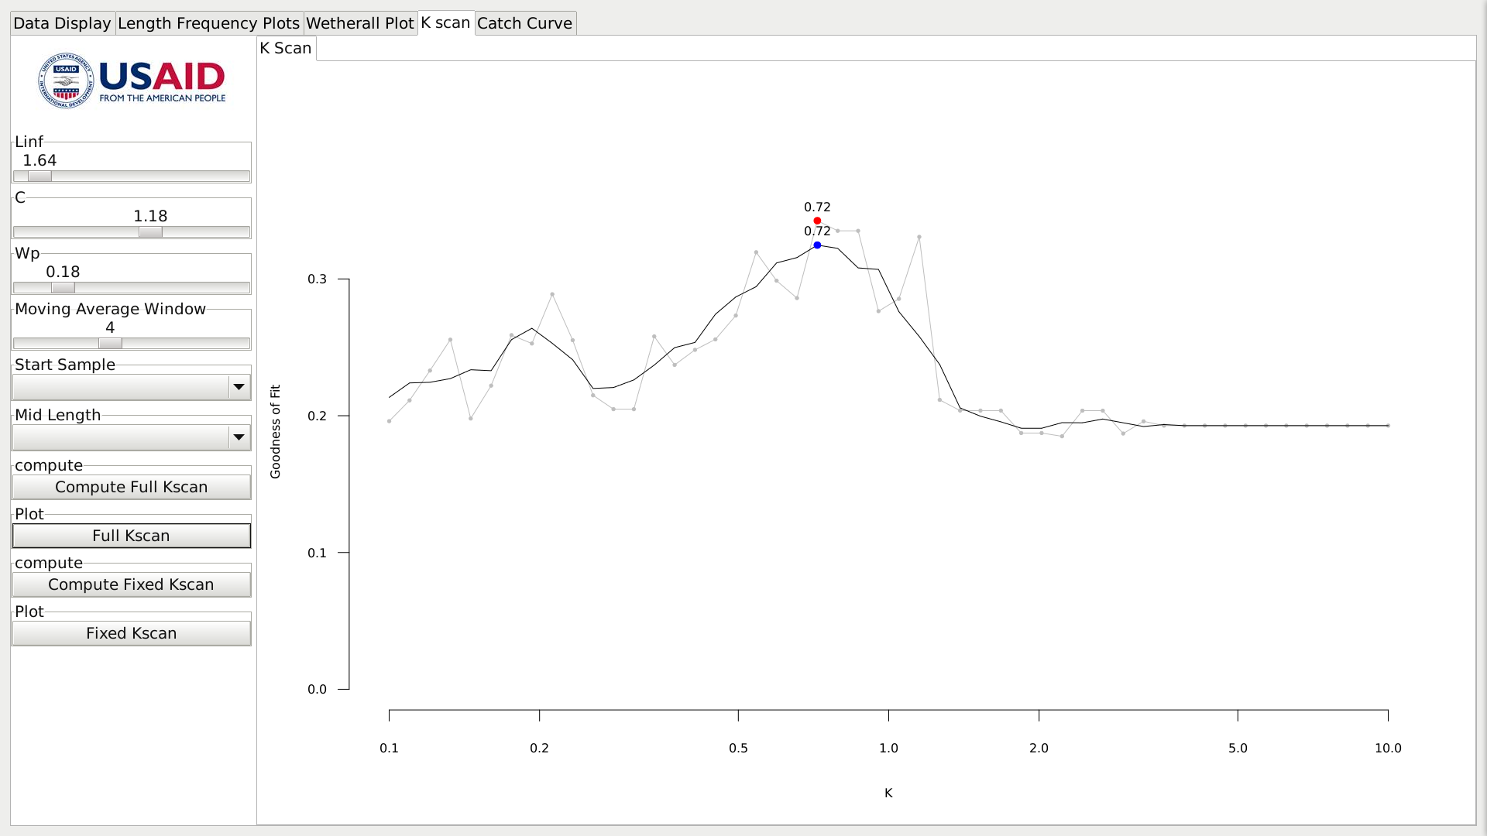This routine both displays the corrected data in the tab called Modified Data and saves the corrected data in a file that allows further analysis.

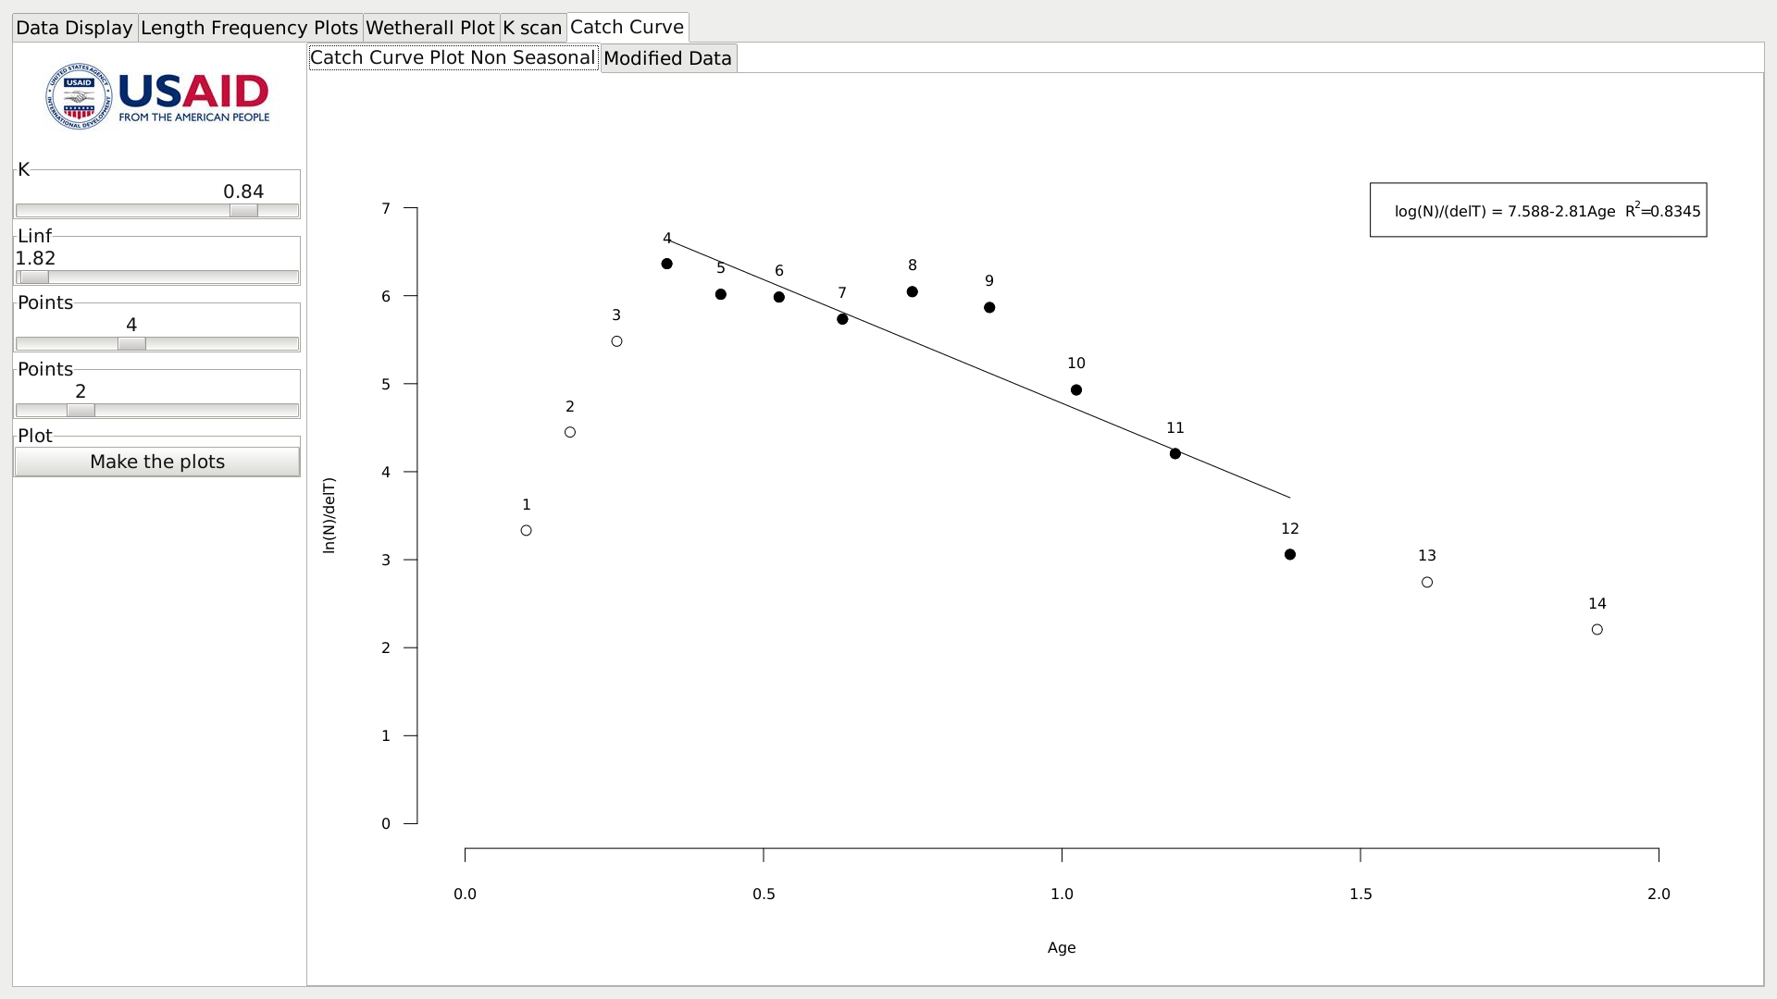

**Acknowledgements**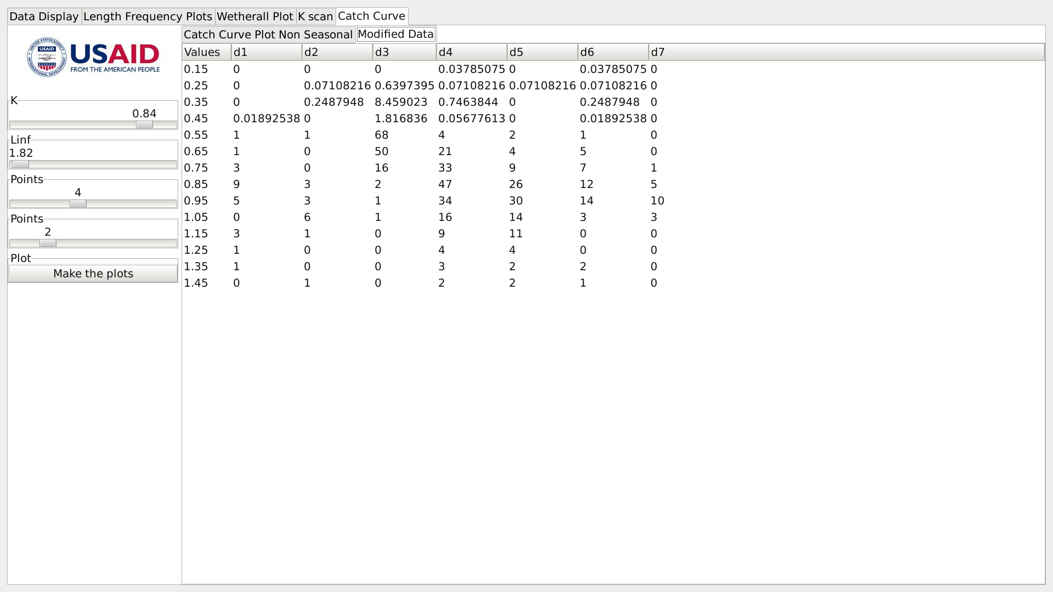

We thank Dr. Christopher Mathews for his enthusiastic support of this new release of ELEFAN. We also thank USAID, for their support of this endeavour. CHRIS: PLEASE EXPAND THE USAID PART AS REQUIRED].

Daniel Pauly also acknowledges support from the Sea Around Us project, a scientific collaboration between the University of British Columbia and the Pew Environment Group.